SNR varied with parameter

Note May 12th

As our polar-coordinates transform and Radon transform might be consistent an have same compute complexity, We take a SNR varied with gridding study with our original method.

Previously review,

SNR varied with Nbins:

Last time , We questioned the method to decide Nbins in rebin step might not be universal. We thought different DM might caused different result to Nbins. I did a simulate at different DM value data and also imply the real data for test. The result keep consistent with previous deduct:

To keep the information conservation, The data after changed should have same pixels as before in order to obtain the most information.

At DM=100 (last time is DM=50), SNR varied with Nbins looks like:

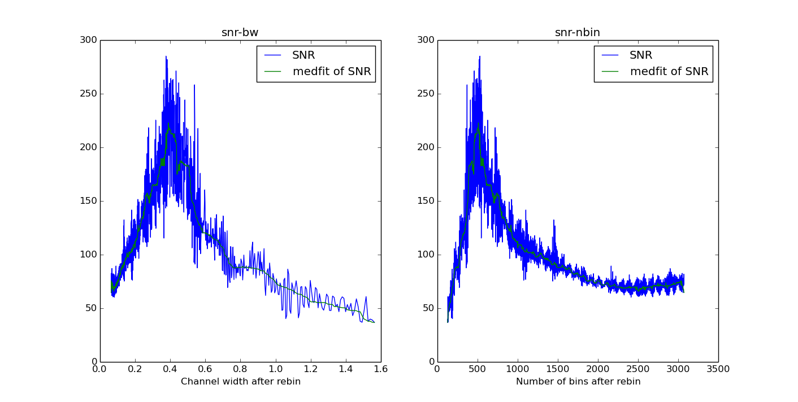(bw means the channel band width which are from : BW/Nbins)

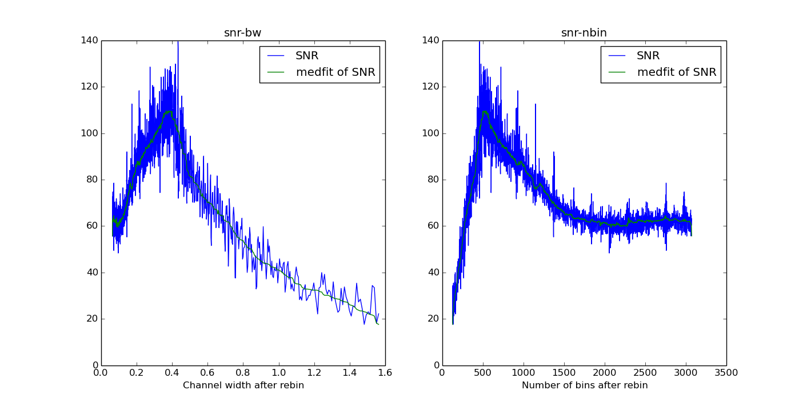This is the DM at 500.

I also test the real data FRB110220, which has a frequency channel number 1024, then when Nbins = 1024 , the SNR getting it’s highest :



SNR varied with resolution:

For the griding problem ( angle resolution problem), I did a test to varied the grid size around the theory value we deduct. And it also looks good .

SNR varied with grid :

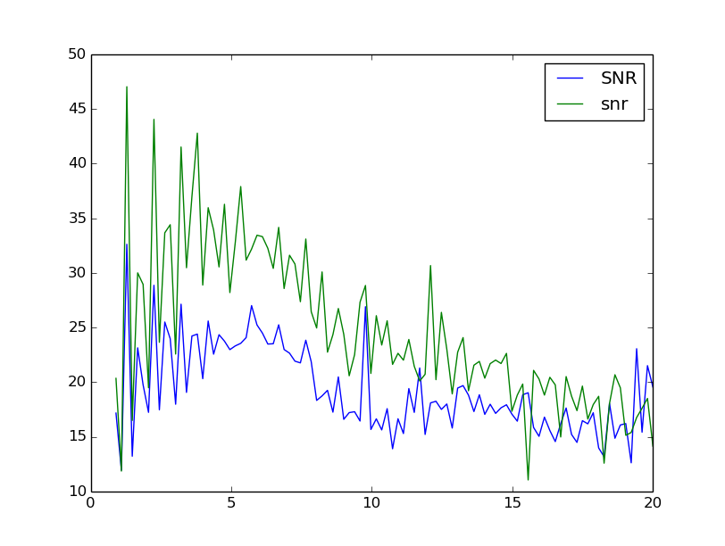

I use grid size max to 20 times bigger than theory grid size which means has higher angle resolution. And get the results like above. To noticed that, the grid size need be a integer, So it will appear some gear shape. But the whole trend is falling down. I did not choose the grid size smaller than 1 time of original grid size which means has lower angle resolution. Because at that time , we could not find signal , the SNR is contribute with wrong point.

Two image can illustrate this,

At original grid size (which means the angle resolution constrained by δDM):

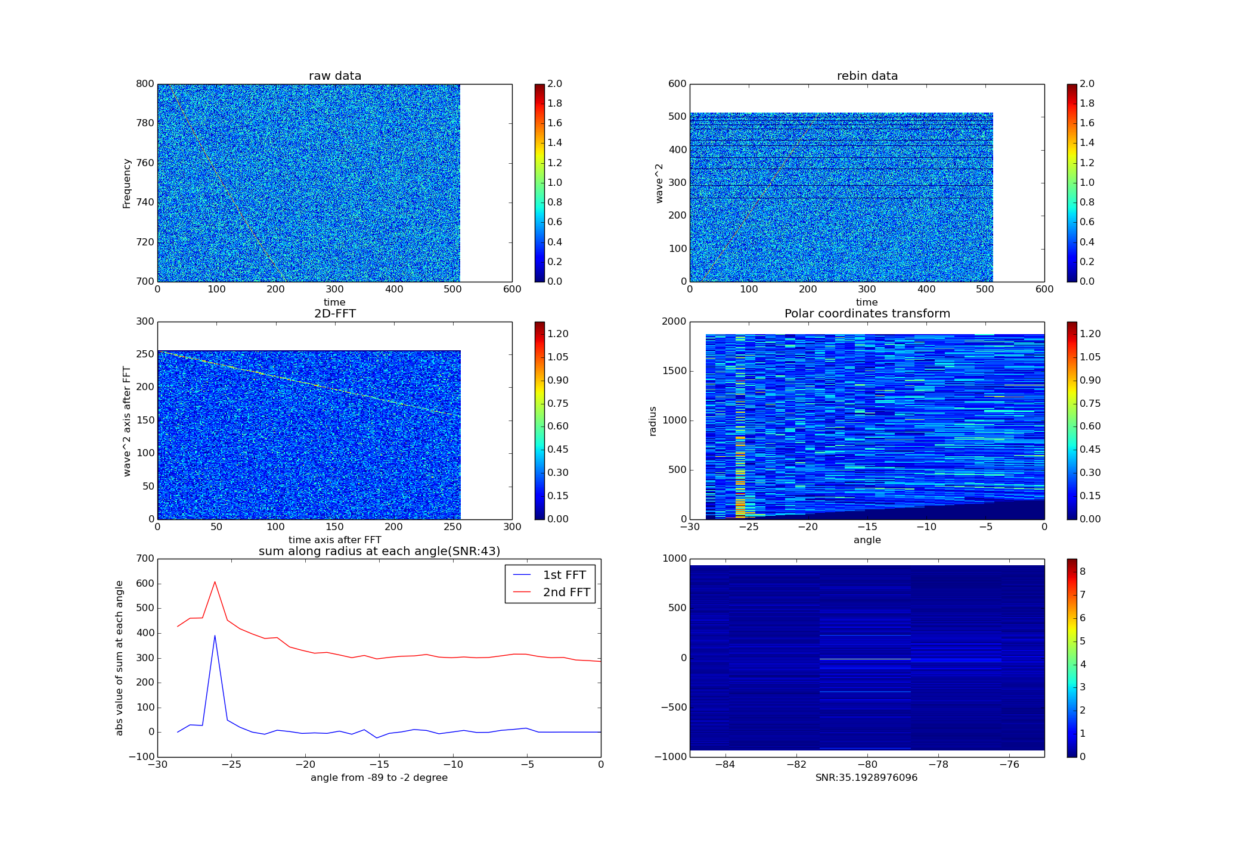

At 0.9 times of grid size (which means it has lower angle resolution):

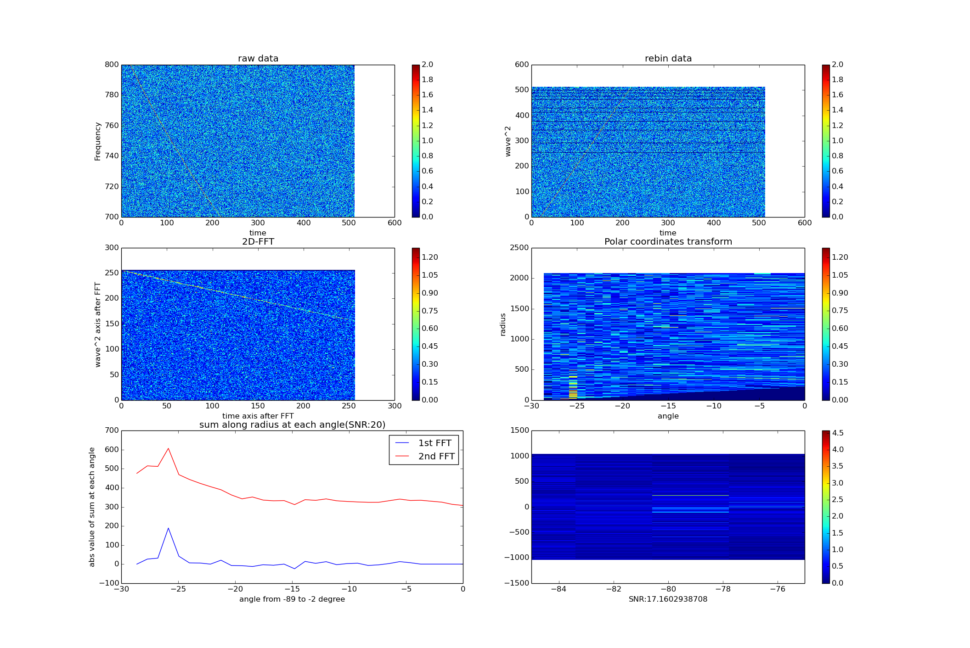We can see the max value of last image is only 4.5 which is smaller than 8 in the original deduct angle resolution.

At 0.8 times of grid size:

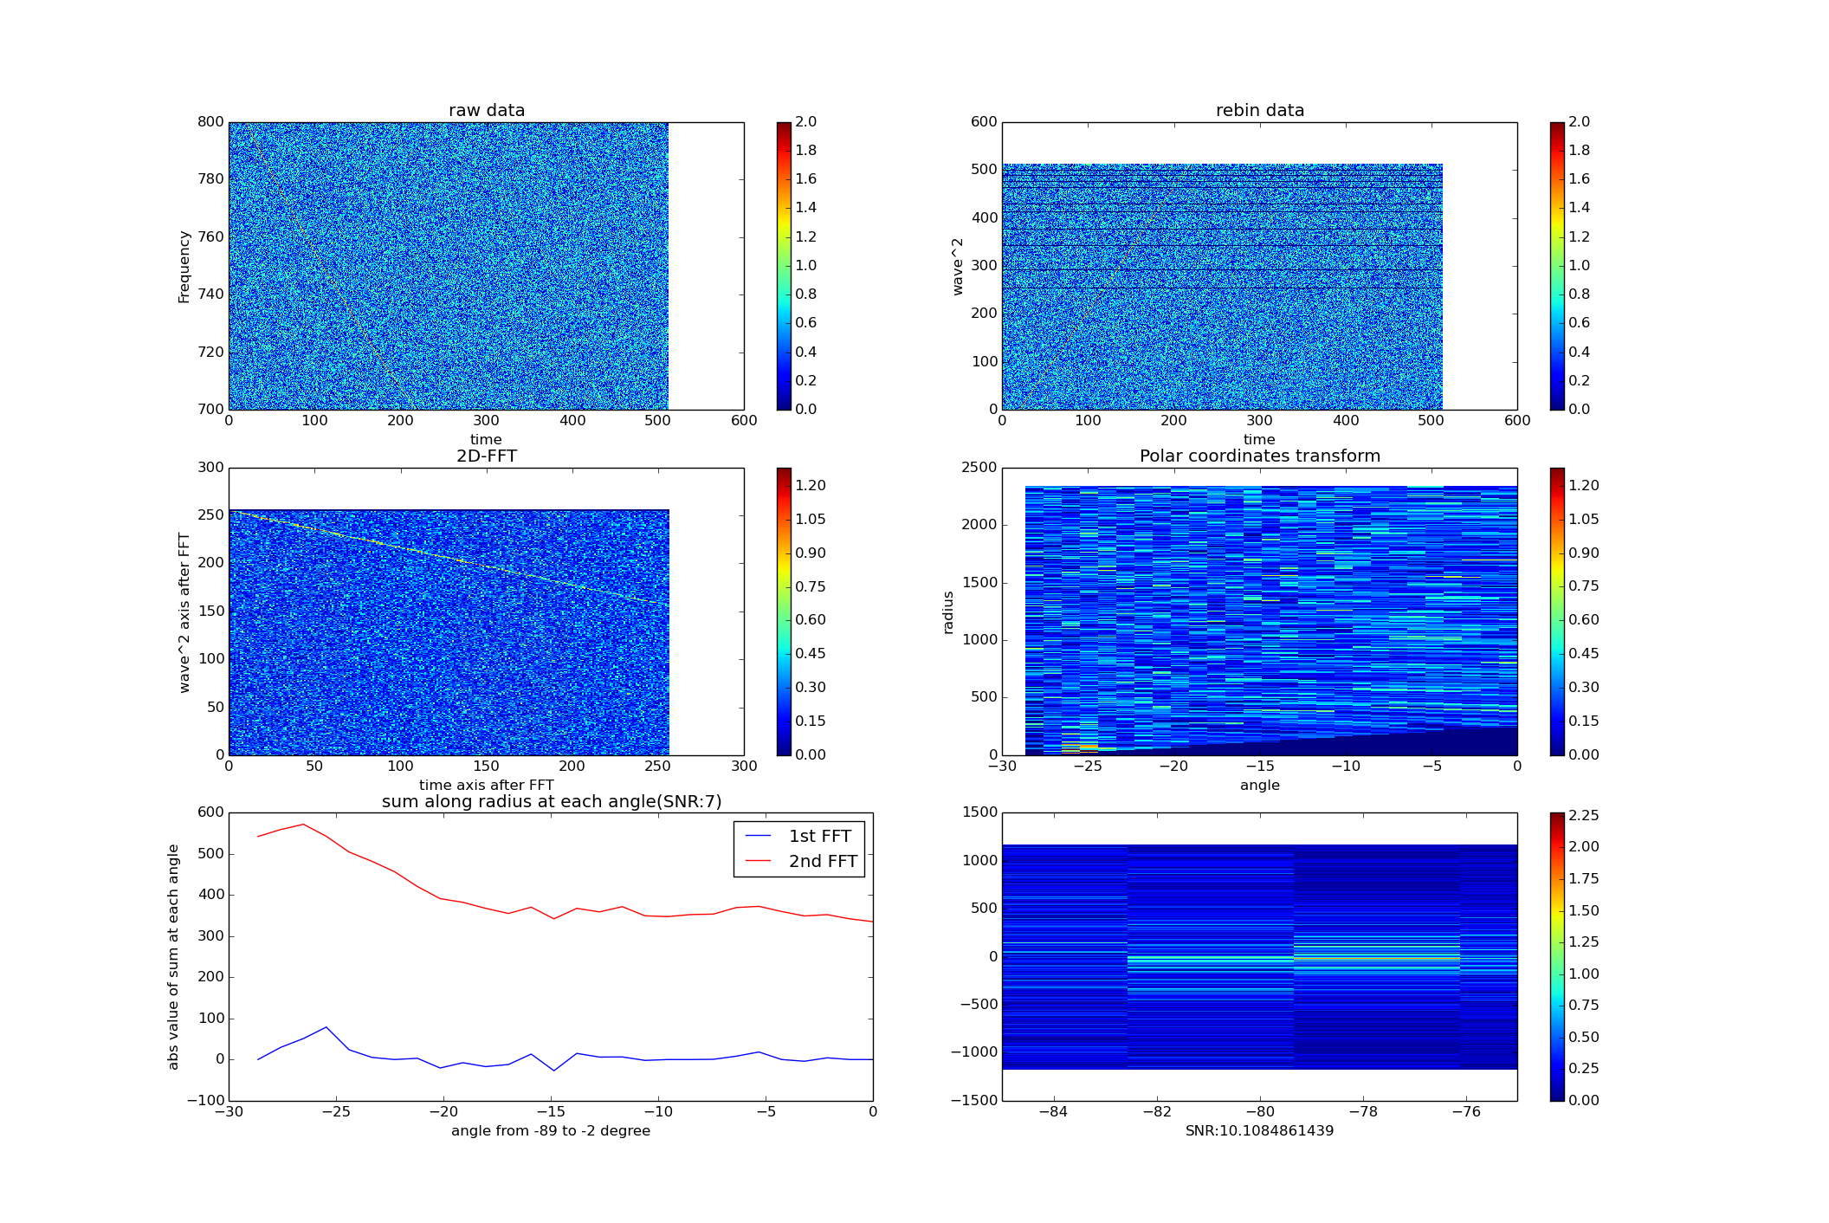The 6th image in above pictures is 2nd 1-D FFT along radius axis. They have been scaled between -84 ~ -75 degree. And we can see the max value pixel is broadening.

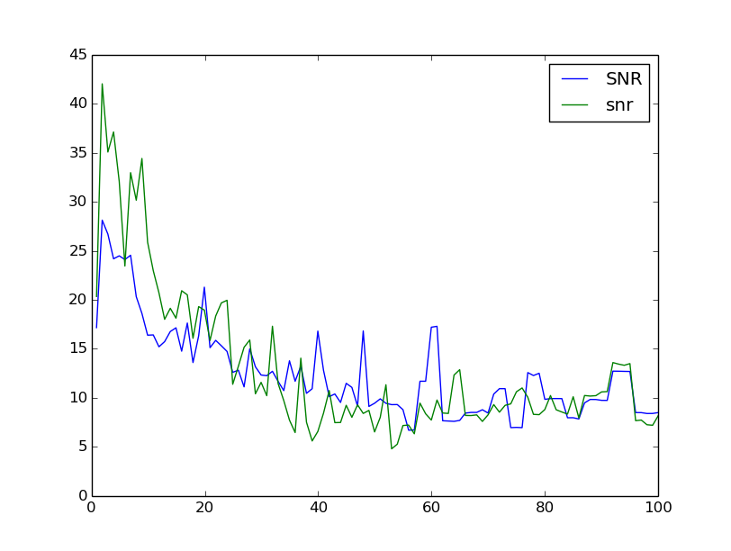To make sure this confection is correct, I also did a extreme test ,that test the grid size 100 times of original size. The SNR is falling obviously.

Conclusion:

Using DM Smearing and pixels information conservation to constrain parameter seems correct. However , we are still facing the problem that tangent function or cotangent function could only be obvious at high or low angle. I am working on to combine them together to have a test recently.